CUSTOMER CHURNING PREDICTION USING XGBOOST

A Project Report Submitted to

JNTUA, Ananthapuramu

In partial fulfillment of the requirements for the award of the degree of

Bachelor of Technology

ARTIFICIAL INTELLIGENCE & DATA SCIENCE
By
M.LAZAR (21KB1A3054)
S.SRI CHARAN (21KB1A3089)
U.SIVA RAJU (21KB1A3093)
Y.SAMSON (21KB1A30A2)
N.CHARAN REDDY (22KB5A3013)

Under the esteemed Guidance of

Mrs. P. JYOTHI, M. Tech
Assistant Professor, Department of IT and AI&DS


DEPARTMENT OF IT and AI&DS
N.B.K.R INSTITUTE OF SCIENCE & TECHNOLOGY
(Autonomous)
VIDYANAGAR – 524 413, TIRUPATI DIST, AP MAY 2025



Website: www.nbkrist.org. Email: ist@nbkrist.org.
Ph: 08624-228 247
Fax: 08624-228 257

N.B.K.R. INSTITUTE OF SCIENCE & TECHNOLOGY
(Autonomous)
(Approved by AICTE: Accredited by NBA: Affiliated to JNTUA, Ananthapuramu) An ISO 9001-2000 Certified Institution
Vidyanagar -524 413, Tirupati District, Andhra Pradesh, India

BONAFIDE CERTIFICATE
This is to certify that the project work entitled “CUSTOMER CHURNING PREDICTION USING XGBOOST ” is a Bonafide work done by M. LAZAR (21KB1A3054), S. SRI CHARAN(21KB1A3089), U. SIVA RAJU (21KB1A3093), Y. SAMSON (21KB1A30A2), N. CHARAN REDDY (22KB5A3013) in the Department of Information Technology and Artificial Intelligence & Data Science, N.B.K.R.Institute of Science & Technology, Vidyanagar and is submitted to JNTUA, Ananthapuramu in the partial fulfilment for the award of B.Tech degree in Artificial Intelligence & Data Science. This work has been carried out under our supervision.

Dr. A. NARAYANA RAO Mrs P. JYOTHI
Professor & Head Assistant Professor
Department of IT and AI&DS Department of IT and AI&DS
NBKRIST, Vidyanagar NBKRIST, Vidyanagar

Submitted for the Viva-Voce Examination held on

Internal Examiner External Examiner

ACKNOWLEDGEMENT

The satisfaction that accompanies the successful completion of a project would be incomplete without the people who made it possible of their constant guidance and encouragement crowned our efforts with success.
We would like to express our profound sense of gratitude to our project guide Mrs. P. Jyothi, Assistant Professor, Department of IT and AI&DS, N.B.K.R.I.S.T (affiliated to JNTUA, Ananthapuramu), Vidyanagar, for his masterful guidance and the constant encouragement throughout the project. Our sincere appreciations for his suggestions and unmatched services without, which this work would have been an unfulfilled dream.
We convey our special thanks to Dr. Y. Venkata Rami Reddy respectable chairman of N.B.K.R. Institute of Science and Technology, for providing excellent infrastructure in our campus for the completion of the project
We convey our special thanks to Sri N. Ram Kumar Reddy respectable correspondent of N.B.K.R. Institute of Science and Technology, for providing excellent infrastructure in our campus for the completion of the project.
We are grateful to Dr. V. Vijaya Kumar Reddy, Director, of N.B.K.R Institute of Science and Technology for allowing us to avail all the facilities in the college.
We would like to convey our heartful thanks to Staff members, Lab technicians, and our friends, who extended their cooperation in making this project as a successful one.
We would like to thank one and all who have helped us directly and indirectly to complete this project successfully.

 |  | Table of Contents
Chapter |  | Topic Name | Page
No |  |  | No
 | Acknowledgement |  | i
 | List of Tables |  | iv
 | List of Figures |  | V
 | Abstract |  | vi
1 | Introduction |  | 1-7
 | 1.1 | Introduction | 2-3
 | 1.2 | Background and Motivation | 3-4
 | 1.3 | Problem Statement | 4
 | 1.4 | Objectives and Scope | 5
 | 1.5 | Organization of the project Report | 6
 | 1.6 | Summary | 7
2 | Literature Review |  | 8-17
 | 2.1 | Introduction | 9
 | 2.2 | Literature Survey | 10-13
 | 2.3 | Identification of Research Gap | 14-16
 | 2.4 | Summary | 17
3 | Methodology |  | 18-26
 | 3.1 | Introduction | 19
 | 3.2 | Overview of Methodological Approach | 19-20
 | 3.3 | Parameters | 21-22
 | 3.3 | Performance Metrics | 23
 | 3.4 | Description of Tools and Technologies Used | 24-25
 | 3.5 | Summary | 26

4 | System Design |  | 27-34
 | 4.1 | Introduction | 28
 | 4.2 | Detailed Design of Components | 29-32
 | 4.3 | UML Diagrams | 33-34
 | 4.4 | Summary | 35
5 | Implementation |  | 36-44
 | 5.1 | Introduction | 37
 | 5.2 | Code Structure and Organization procedure | 38-39
 | 5.3 | Algorithms and Techniques Implemented | 40-43
 | 5.4 | Summary | 44
6 | Results and Analysis |  | 45-57
 | 6.1 | Introduction | 46
 | 6.2 | Results | 47-53
 | 6.3 | Analysis of Performance Metrics | 54
 | 6.4 | Discussion of Findings | 55-56
 | 6.5 | Summary | 57
7 | Conclusion and Future Work |  | 58-61
 | 7.1 | Conclusions Drawn from the Study | 59
 | 7.2 | Limitations and Challenges Encountered | 60
 | 7.3 | Suggestions for Future work | 61
8 | References |  | 62-64
 |  | List of References Cited in the Report | 63-64
9 | Appendices |  | 65-68
 |  | User Manuals or Documentation | 66-68

List of Tables

Table No. | Table Name | Page No
3.1 | Data Attributes | 21
6.1 | Data | 47
6.2 | Train Data results | 50
6.3 | Test Data results | 50

List of Figures

Figure No. | Figure Name | Page No
3.1 | Methodology overview | 19
4.1 | System design | 28
4.2 | Data Preparation | 29
4.3 | Data Preprocessing | 30
4.4 | Exploratory Data Analysis | 30
4.5 | Model Selection | 31
4.6 | Model Evaluation | 31
4.7 | Prediction Model | 32
4.8 | Activity diagram of flask application | 33
5.5 | XG boost | 43
6.1 | Correlation with performance score | 47
6.2 | Univariate analysis graphs | 48
6.3 | Multivariate analysis graphs | 49
6.4 | Model comparison | 50
6.5 | Login page | 51
6.6 | Home page | 51
6.7 | Summary Statistics | 52
6.8 | Visualization | 52
6.9 | Prediction page | 53
6.10 | Prediction result | 53

ABSTRACT

In today’s competitive business environment, customer retention is a key priority, as losing customers directly impacts revenue and growth. Early prediction of customer churn enables companies to implement proactive strategies to retain clients. This study focuses on enhancing churn prediction using machine learning algorithms on a dataset consisting of 7043 customer records and 21 features collected over a nine-month period preceding churn. To improve model accuracy and reliability, several advanced data preprocessing techniques were employed, including SMOTE for handling class imbalance, outlier detection and treatment to enhance data quality, and feature engineering to derive new variables that uncover deeper patterns. Additionally, Principal Component Analysis (PCA) was applied to reduce dimensionality and mitigate overfitting. The study evaluated traditional models such as Logistic Regression, K-Nearest Neighbors (KNN), and Random Forest alongside advanced gradient boosting methods like XGBoost . Results indicate that the integration of robust preprocessing techniques with gradient boosting algorithms significantly improves churn prediction performance. This approach offers a practical and scalable solution for businesses to identify at-risk customers, optimize retention strategies, and enhance profitability through more informed customer relationship management.

CHAPTER-1

INTRODUCTION

Introduction

In an era of heightened market competition and increasingly discerning consumers, businesses face significant challenges in maintaining customer loyalty. While acquiring new clients is essential, it is far more cost-effective to retain existing ones, making customer retention a key driver of long-term profitability. One of the most pressing concerns in this domain is customer churn—the phenomenon wherein clients discontinue their services. Churn prediction enables organizations to proactively identify at-risk customers and take strategic actions to mitigate attrition, thereby preserving revenue streams and enhancing customer satisfaction.
Previous studies, including the work by Prabadevi et al. (2023), have explored the utility of machine learning (ML) algorithms in churn analysis. Their study evaluated the performance of algorithms such as stochastic gradient booster (SGB), random forest (RF), k-nearest neighbors (KNN), and logistic regression (LR) using a dataset with customer behavior spanning nine months prior to churn. The findings demonstrated promising results, with SGB yielding the highest prediction accuracy (AUC = 0.84). However, the study largely focused on direct application of these models with conventional preprocessing, without incorporating advanced data enhancement techniques.
This research builds upon and advances the existing body of work by proposing a more comprehensive and refined approach to churn prediction. The study introduces a multi-faceted preprocessing pipeline that includes Synthetic Minority Over-sampling Technique (SMOTE) to address class imbalance, systematic outlier detection and handling, and sophisticated feature engineering to uncover hidden patterns in customer behavior. Dimensionality reduction through Principal Component Analysis (PCA) is also employed to enhance model efficiency and reduce the risk of overfitting.
Further, the study integrates powerful gradient boosting techniques—namely XGBoost, which have demonstrated superior performance in capturing nonlinear patterns and handling categorical data effectively. These models are benchmarked against traditional algorithms to evaluate their predictive power and practical applicability in real-world churn scenarios.

Background and Motivation:

    - Background

Customer churn refers to the process where customers discontinue using a company's services or switch to a competitor. It is especially critical in subscription-based industries like telecommunications, banking, and online services, where customer retention plays a key role in long-term profitability. As markets become more saturated and customer expectations evolve, predicting churn has become a strategic business priority.

With the growth of big data and machine learning (ML), organizations now have access to tools that can help identify patterns in customer behavior leading to churn. Past research has explored various ML algorithms—such as logistic regression, K-nearest neighbors (KNN), random forest, and gradient boosting—for churn prediction, often yielding promising results. For instance, the study by Prabadevi et al. (2023) applied these models and found that stochastic gradient boosting (SGB) outperformed the others in prediction accuracy.

However, many existing studies do not fully address key data challenges such as class imbalance, the presence of outliers, or high-dimensional features that can affect the performance of machine learning models. These limitations highlight the need for more comprehensive preprocessing techniques and the adoption of advanced models capable of handling complex and noisy datasets.

Motivation

Customer churn presents a substantial challenge for organizations that rely on long-term customer engagement, especially in subscription-based industries. Although machine learning techniques have been increasingly adopted for churn prediction, many existing models are limited by simplistic preprocessing and outdated algorithms. To build models that are both accurate and applicable in real-world business settings, there is a strong need to incorporate more advanced data treatment methods and leverage powerful modern algorithms that can better understand complex patterns in customer behavior.

- Data Complexity: Real-world customer datasets often exhibit issues such as class imbalance—where churned customers make up a small portion of the data—leading to biased models. Additionally, noisy or redundant features and outliers can significantly distort predictions if not properly managed. Addressing these issues through techniques like SMOTE for oversampling, outlier detection, and feature scaling is crucial for building robust models.

- Limitations of Prior Work: While earlier studies, including the work by Prabadevi et al. (2023), applied models like logistic regression, KNN, and stochastic gradient boosting, they lacked advanced preprocessing techniques and did not explore high-performance algorithms like XGBoost. These newer algorithms offer superior handling of categorical data, better regularization, and improved generalization, which are essential for capturing complex customer behavior.
- Business Impact: Accurate churn prediction has a direct impact on profitability by enabling businesses to take proactive measures before a customer leaves. An improved model can segment at-risk customers more effectively, allowing companies to implement targeted retention strategies such as personalized offers or service improvements, thereby reducing churn rates and enhancing customer satisfaction and loyalty.

Problem Statement

Customer churn significantly affects business revenue, especially in industries where customer acquisition costs are high. Although various machine learning models have been used for churn prediction, many fail to handle real-world challenges such as class imbalance, outliers, and high-dimensional data. Traditional models often produce moderate accuracy and lack generalizability. Existing studies, including Prabadevi et al. (2023), have not fully utilized advanced preprocessing techniques or more powerful boosting algorithms. This limits the models’ ability to detect complex customer behavior patterns. There is a need for a robust and scalable solution that improves prediction accuracy. This study aims to address these gaps by integrating modern preprocessing methods and advanced machine learning algorithms to enhance churn prediction performance.

Objectives And Scope

Objectives:

- To analyze customer churn behavior using historical data to understand key factors contributing to customer attrition.
- To preprocess the dataset effectively by handling missing values, detecting and treating outliers, and encoding categorical variables.
- To address class imbalance in the dataset using the SMOTE (Synthetic Minority Over-sampling Technique) method to improve model fairness and accuracy.
- To apply feature engineering to create new, more informative features that better capture customer behavior patterns.

- To reduce dimensionality using Principal Component Analysis (PCA) to minimize overfitting and improve model generalization.

- To implement multiple machine learning algorithms, including Logistic Regression, K-Nearest Neighbors (KNN), Random Forest, XGBoost.
- To optimize model hyperparameters using Grid Search CV and Randomized Search CV for improved predictive performance.

- To compare the performance of traditional and advanced models based on evaluation metrics such as accuracy, precision, recall, F1-score, and AUC-ROC.

Scopes:

- Dataset Focus: This study is limited to a publicly available telecommunications customer churn dataset consisting of 7,043 entries and 21 features, including demographic data, service details, and billing information.
- Analytical Scope: The project focuses on the application of supervised machine learning techniques for churn prediction, covering data preprocessing, model training, performance evaluation, and comparison. Real-time deployment and business integration are outside the scope of this research.

Organization Of The Project Report

    - Introduction: This chapter provides an overview of the research topic, highlighting the importance of churn prediction in modern businesses. It includes the background, motivation, problem statement, objectives, and scope of the study.

    - Literature Review: This section reviews existing studies and methodologies related to churn prediction. It summarizes various machine learning techniques previously used, their strengths, and their limitations, providing a foundation for the proposed approach.

    - Methodology: This chapter outlines the detailed methodology followed in the project. It includes dataset description, preprocessing steps (e.g., handling outliers, SMOTE, feature engineering, and PCA), model selection, and training process.

    - Materials and Methods: Details This section discusses the implementation of selected machine learning algorithms (Logistic Regression, KNN, Random Forest, XGBoost, ) and presents a comparative analysis of their performance based on accuracy, precision, recall, F1-score, and AUC-ROC.

    - Implementation and Results: Explains the architecture of the proposed DCNN model and its components. It also describes the transfer learning models— AlexNet, ResNet, VGG-16, DenseNet, and MobileNet—that were trained and evaluated on the same dataset for performance comparison.

    - Discussion: This chapter interprets the results, highlighting the strengths and weaknesses of each algorithm in the context of churn prediction, and discusses the business implications of the findings.

    - Conclusion and Future Work: The final chapter summarizes the research contributions and findings. It also outlines potential future enhancements, including model deployment, real-time integration, and the application of deep learning techniques.

Summary

This project focuses on the development of a machine learning-based framework for predicting customer churn, a critical factor in ensuring business sustainability and customer retention. The study begins with an introduction to the concept of churn and its impact on business, followed by a detailed background highlighting the current challenges in churn prediction, such as class imbalance, data quality issues, and limited use of advanced algorithms.

The motivation behind the study stems from the limitations of prior work, particularly the need for better data preprocessing and the use of more powerful models like XGBoost . A clear problem statement is outlined, emphasizing the need for more accurate and generalizable models. The project sets out ten specific objectives, including preprocessing the dataset, applying dimensionality reduction, evaluating multiple algorithms, and developing a business-ready prediction framework.

The scope is clearly defined, focusing on a telecommunications dataset and the use of supervised learning techniques without delving into real-time deployment. The report is organized into structured chapters, covering the introduction, literature review, methodology, implementation, results, discussion, and conclusion. Each chapter builds upon the previous to provide a comprehensive and practical approach to improving churn prediction using advanced machine learning techniques.

CHAPTER-2

LITERATURE SURVEY

Introduction

Customer churn prediction has become a central focus in data-driven decision-making, particularly in industries where retaining existing customers is more profitable than acquiring new ones. As businesses strive to reduce attrition rates and increase customer lifetime value, machine learning (ML) techniques have emerged as effective tools for modeling churn behavior based on historical customer data.

Numerous studies have explored different ML approaches for churn prediction, utilizing classification models such as logistic regression, decision trees, support vector machines (SVM), random forest, and gradient boosting techniques. These models help identify patterns in customer demographics, service usage, payment methods, and contract terms that contribute to churn.

The literature reveals a growing trend toward ensemble and boosting methods like XGBoost due to their ability to handle imbalanced datasets, high-dimensional features, and nonlinear relationships. Despite these advancements, many previous works either lack comprehensive data preprocessing or overlook critical model optimization steps, leading to suboptimal results.

This chapter reviews significant contributions to the field of churn prediction, discusses the techniques employed, their advantages and limitations, and identifies the research gaps that this project aims to address.

Literature Survey

A wide range of machine learning (ML) techniques have been explored for predicting customer churn across various industries, particularly in the telecommunications sector where competition is intense and customer retention is crucial. This section reviews key contributions in the domain, focusing on methodologies, datasets, algorithms used, and their respective outcomes.

Study by Prabadevi et al. (2023)
Prabadevi et al. conducted a comprehensive analysis of customer churn using a dataset of 7044 entries from a telecom company. They implemented and compared the performance of four supervised ML algorithms: Stochastic Gradient Booster (SGB), Random Forest (RF), Logistic Regression (LR), and K-Nearest Neighbors (KNN). The SGB model achieved the highest test accuracy (79.14%) and an AUC of 0.839, indicating its effectiveness in modeling customer churn. Their study involved basic preprocessing techniques such as label encoding and one-hot encoding but did not incorporate advanced data treatment like SMOTE, feature engineering, or dimensionality reduction.

Omar Adwan et al.
Applied Multi-layer Perceptron Neural Networks (MLPNN) for churn prediction in the telecommunications industry. Using real customer data from a Jordanian telecom provider, the study showed that deep learning approaches could offer high precision in detecting churn patterns, though they typically require more computational resources and longer training times.

Ismail et al.
Explored the effectiveness of MLPNNs in a Malaysian telecom setting and compared results with traditional methods such as regression and classification. Their findings emphasized the need for carefully tuned neural network architectures to outperform classical models.

Ullah et al.
Developed a churn prediction model using Random Forests and K-Means clustering. They reported an accuracy of up to 79% and highlighted the importance of hybrid models that combine classification and segmentation to better identify churn-prone customers.

Edwine et al.
Performed a comparative analysis of KNN, RF, and SVM, further enhanced by hyperparameter optimization using Grid Search. Their findings supported the use of ensemble methods, especially when combined with parameter tuning and balancing techniques, to improve churn prediction outcomes.

Limitations Identified in Existing Works
While many of these studies achieved reasonable prediction accuracy, they often lacked:

Comprehensive preprocessing techniques, such as handling of class imbalance (e.g., SMOTE) or dimensionality reduction (e.g., PCA).

Feature engineering, which is essential for capturing deeper patterns in customer behavior.The application of modern gradient boosting algorithms, such as XGBoost, which have shown superior performance in handling categorical data and complex feature interactions.

Identification of Research Gap.

While significant research has been conducted in the area of customer churn prediction, several critical gaps remain that limit the effectiveness and scalability of existing models in real-world business environments. The literature, including the work by Prabadevi et al. (2023), has demonstrated the potential of machine learning models like Logistic Regression, K-Nearest Neighbors (KNN), Random Forest, and Stochastic Gradient Booster (SGB) in churn classification. However, their study—and many similar ones—falls short in several key areas:
- Lack of Advanced Data Preprocessing Techniques: Many existing studies, including the base paper, apply basic data cleaning and encoding but do not fully address class imbalance using techniques such as SMOTE. This can lead to biased models that underperform in correctly identifying minority class instances (i.e., churners).
- Limited Feature Engineering and Outlier Handling: There is minimal application of feature engineering to create new variables that capture deeper behavioral patterns. Outlier detection and treatment, which can significantly impact model performance, are also often overlooked.
- No Use of Dimensionality Reduction Techniques: High-dimensional data can lead to overfitting and reduced model generalization. However, dimensionality reduction techniques like Principal Component Analysis (PCA) are rarely utilized in churn studies, including the referenced base paper.
- Underutilization of Advanced Algorithms: Despite their proven effectiveness, algorithms like XGBoost are not explored in most traditional churn prediction studies. These models offer better handling of categorical data, improved accuracy, and built-in regularization features that help reduce overfitting.
- Limited Focus on Real-World Model Generalization: Many studies demonstrate high accuracy on a specific dataset but do not consider model scalability, interpretability, or integration into business decision-making processes.

Summary

The current landscape of customer churn prediction using machine learning techniques, with a focus on existing methodologies, their strengths, and limitations. It reviewed various studies, including the base paper by Prabadevi et al. (2023), which utilized models such as Logistic Regression, K-Nearest Neighbors, Random Forest, and Stochastic Gradient Booster. While these models achieved moderate to high accuracy, the chapter highlighted that most studies lacked comprehensive preprocessing techniques, such as class balancing, outlier detection, and dimensionality reduction.

The review also revealed a consistent underutilization of advanced algorithms like XGBoost , which are better suited for capturing complex patterns in customer data. Additionally, the literature emphasized the need for improved feature engineering and a stronger focus on real-world model applicability.

By identifying these limitations, this chapter establishes a clear research gap, setting the foundation for the methodology proposed in the next chapter. The aim is to develop a more robust, accurate, and practical churn prediction model that addresses these shortcomings through advanced preprocessing and modern machine learning approaches.

CHAPTER-3

METHODOLOGY

Introduction

This chapter outlines the methodology adopted for developing an enhanced customer churn prediction model using machine learning techniques. Building on the limitations identified in previous studies, including the base paper by Prabadevi et al. (2023), the proposed approach incorporates advanced data preprocessing and the application of powerful ensemble learning algorithms to improve prediction accuracy and model robustness.

The methodology is designed to address critical issues such as class imbalance, feature redundancy, overfitting, and the lack of modern boosting methods. It includes systematic steps for data cleaning, outlier handling, feature engineering, class balancing using SMOTE, and dimensionality reduction using Principal Component Analysis (PCA). Following preprocessing, multiple machine learning algorithms—both traditional (Logistic Regression, K-Nearest Neighbors, Random Forest) and modern (XGBoost)—are trained and evaluated using performance metrics such as accuracy, precision, recall, F1-score, and AUC-ROC.

This chapter details each stage of the process, from data collection and preparation to model training and evaluation, providing a comprehensive framework aimed at delivering a more reliable and scalable churn prediction solution

Overview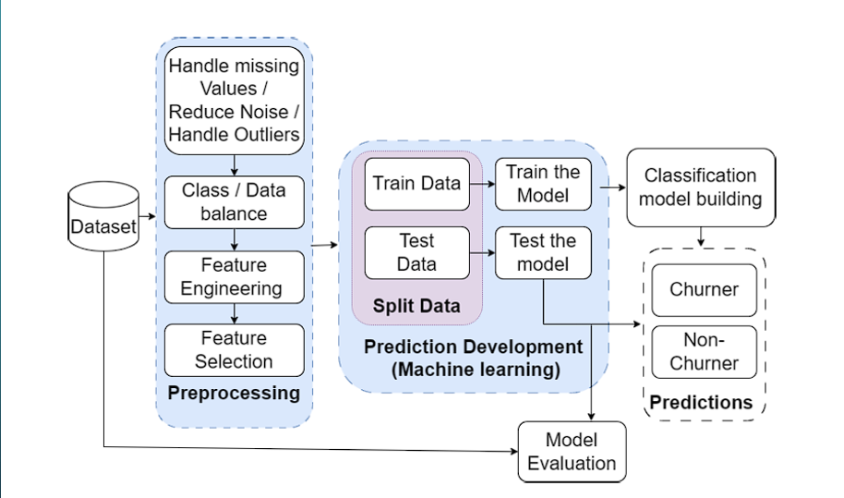
Fig 3.1 Methodology overview

The following diagram (Fig 3.1) illustrates the complete methodology adopted for Customer churn prediction using xgboost machine learning algorithms. It outlines the major steps involved in the process, from data input to final classification, offering a clear picture of the workflow implemented in the project.

- Data Preprocessing: The first and most critical step in customer churn prediction is data preprocessing. This stage involves cleaning the dataset by handling missing values, reducing noise, and managing outliers to ensure the quality and reliability of the input data. Since customer churn datasets often suffer from class imbalance—where the number of churners is significantly lower than non-churners—techniques like oversampling, undersampling, or using class weights are applied to balance the data. Next, feature engineering is performed to create new, meaningful attributes from existing ones that can help the model better understand customer behavior. After that, feature selection is used to eliminate irrelevant or redundant features, improving both model performance and training speed.

- Prediction Development Using XGBoost : Once preprocessing is complete, the dataset is split into training and testing sets, usually in an 80:20 or 70:30 ratio. This is followed by the prediction development phase, where machine learning models such as XGBoost are trained. XGBoost (Extreme Gradient Boosting) is highly efficient for structured data and offers excellent accuracy and speed. (Categorical Boosting), on the other hand, is particularly advantageous when working with categorical data, as it handles these features natively without requiring one-hot or label encoding. During this stage, the models learn patterns from the training data and are then evaluated on the test data to assess their generalization capability.

- Model Evaluation: Model evaluation is a crucial step in understanding how well the trained model performs. Various evaluation metrics are used, such as accuracy, precision, recall, F1-score, and AUC-ROC, to measure the model's effectiveness in predicting churn. If the model's performance is not satisfactory, techniques like hyperparameter tuning (using grid search or random search) can be applied to optimize its behavior. Additionally, both XGBoost offer feature importance insights, which help identify the most influential factors contributing to customer churn.

- Classification Model Building: After evaluating and fine-tuning the models, the next step is to build a classification model. This model is capable of categorizing customers into two classes: “Churners” (those likely to leave the service) and “Non-Churners” (those likely to stay). This classification helps businesses to target specific customer groups and develop effective retention strategies.

- Final Predictions and Deployment: In the final stage, the trained and validated model is used to make predictions on new or unseen customer data. These predictions provide actionable insights that companies can use to proactively identify at-risk customers and take steps to retain them. With the high accuracy and interpretability provided by models like XGBoost , the customer churn prediction system becomes a powerful tool in business decision-making

Data set and Parameters

    - Data set : Table 3.1 shows the attributes included I the data set used for project.

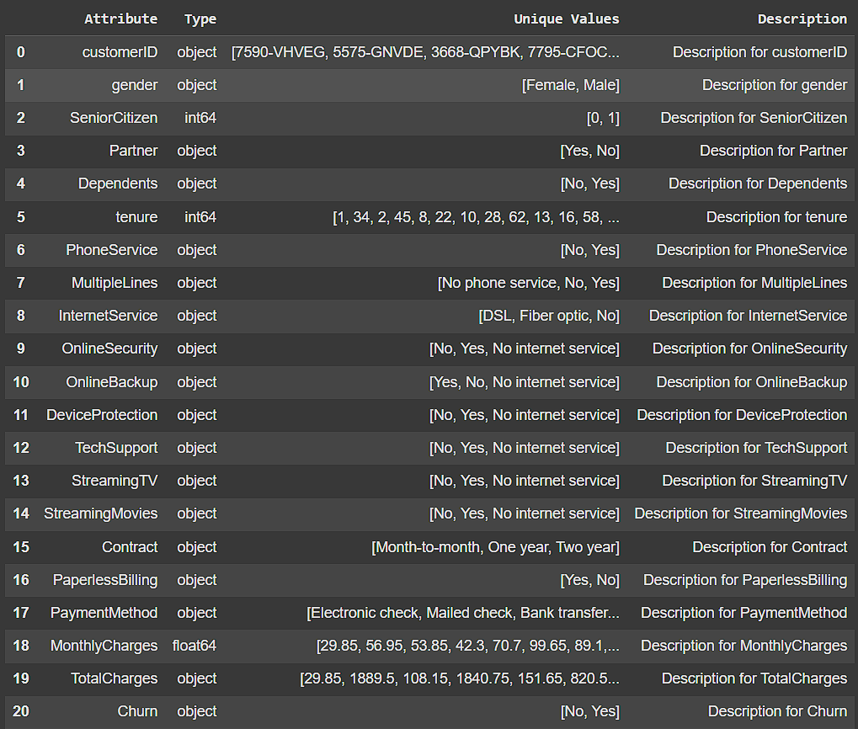

Table 3.1 Data Attributes

Parameters

1. Data Collection & Preparation
  - Data sources (CRM, website activity logs, call center data, etc.)
  - Time frame of data (last 6 months, 1 year, etc.)
  - Customer identifiers (customer ID, account number)
  - Missing value handling (mean/mode imputation, deletion, etc.)
  - Data balancing (e.g., SMOTE for class imbalance)

2. Feature Engineering
  - Demographic features (age, gender, income)
  - Behavioral features (usage frequency, purchase history)
  - Engagement metrics (login frequency, support tickets raised)
  - Time-based features (tenure, days since last purchase)
  - Churn label definition (inactive for 90 days, service canceled, etc.)
3. Model Selection & Training
  - Algorithms (Logistic Regression, Random Forest, XGBoost)
  - Train-test split ratio (80:20)
  - Cross-validation strategy (K-Fold, Stratified K-Fold)
  - Hyperparameters (learning rate, max depth, number of trees, regularization)
4. Model Evaluation
  - Metrics (Accuracy, Precision, Recall, F1-Score, ROC-AUC)
  - Confusion matrix (TP, FP, TN, FN analysis)
5. Deployment & Monitoring
  - Prediction frequency (real-time, daily, weekly)
  - Model update frequency (monthly retraining, drift detection)
  - Threshold setting (probability cutoff for classifying churn)
  - Monitoring KPI (churn rate, model accuracy over time)

Performance Metrics

- Accuracy
Accuracy measures the overall correctness of the model
Formula:
Accuracy = (TP + TN) / (TP + TN + FP + FN)
Where:
TP = True Positives
TN = True Negatives
FP = False Positives
FN = False Negatives

2. Precision
Precision measures how many of the positively predicted cases are actually positive.
Formula:
Precision = TP / (TP + FP)

3. Recall (Sensitivity)
Recall indicates how many actual positive cases were correctly identified by the model.
Formula:
Recall = TP / (TP + FN)

4. F1-Score
F1-score is the harmonic mean of precision and recall, and it provides a balance between the two.

Formula:
F1-Score = 2 * (Precision * Recall) / (Precision + Recall)

5. ROC-AUC (Receiver Operating Characteristic – Area Under Curve)
The ROC-AUC score represents the model’s ability to distinguish between the positive and negative classes. A higher AUC indicates better discriminatory performance.

Description of Tools and Technologies Used

1. Python (Version 3.10.6)
Python serves as the primary programming language for this project due to its simplicity, extensive libraries, and strong community support in the data science ecosystem. It allows seamless integration of data processing, machine learning, and visualization workflows.

2. Jupyter Notebook (Anaconda Distribution)
Jupyter Notebook, an open-source web-based environment, was used for interactive coding and step-by-step execution of the entire machine learning pipeline. It supports visualizing data outputs and debugging, making it ideal for iterative development and experimentation.

3. Numpy and Pandas
Numpy: Used for numerical computing and handling multi-dimensional arrays and matrices.
Pandas: Essential for data manipulation and preprocessing, including loading datasets, handling missing values, and transforming features.

4. Scikit-learn
Scikit-learn is the core machine learning library used in the project. It provides tools for:
Data proprocessing (e.g., label encoding, one-hot encoding, standardization)
Splitting datasets into training and testing sets
Model implementation (e.g., Logistic Regression, KNN, Random Forest)
Performance metrics (e.g., accuracy, precision, recall, F1-score, AUC)

5. Matplotlib and Seaborn
These Python libraries are used for data visualization.
Matplotlib: Generates static, animated, and interactive plots.

Seaborn: Built on top of Matplotlib, it provides a high-level interface for drawing attractive and informative statistical graphics.

6. XGBoost
XGBoost: An optimized gradient boosting library designed for speed and performance. It handles sparse data well and includes regularization, which helps prevent overfitting.

: A high-performance gradient boosting algorithm developed by Yandex, specifically designed to handle categorical variables without requiring manual encoding.

7. SMOTE (Synthetic Minority Over-sampling Technique)
Implemented using the imblearn library, SMOTE is used to address the issue of class imbalance by generating synthetic samples for the minority class (i.e., churned customers).

3.5 Summary

This chapter presented the methodology followed to build an effective customer churn prediction model using machine learning. The chapter began with an overview of the approach and detailed each stage, starting from data preprocessing to model evaluation. Special focus was given to handling real-world challenges such as class imbalance, outliers, and high-dimensional features. Techniques like SMOTE for balancing, feature engineering, and PCA for dimensionality reduction were applied to enhance model performance and generalization.

Multiple machine learning algorithms were implemented, including traditional methods such as Logistic Regression, K-Nearest Neighbors (KNN), and Random Forest, along with advanced gradient boosting algorithms like XGBoost . The models were evaluated using standard performance metrics such as accuracy, precision, recall, F1-score, and ROC-AUC, ensuring a comprehensive assessment.

The chapter also discussed the tools and technologies used, including Python, Jupyter Notebook, Scikit-learn, and visualization libraries like Matplotlib and Seaborn. Overall, this methodology provides a robust and scalable framework for predicting churn, laying the groundwork for the implementation and analysis detailed in the next chapter.

CHAPTER-4

SYSTEM DESIGN

Introduction

System design plays a vital role in ensuring that the machine learning-based customer churn prediction system functions efficiently, accurately, and is scalable for real-world applications. This chapter presents the architectural layout and design components used in the development of the proposed churn prediction framework. The design process encompasses the flow of data, the interaction between components, and the stages involved in model training, validation, and evaluation.

The goal of the system is to process customer data, apply machine learning algorithms, and output predictions that identify customers who are likely to churn. To achieve this, the system is structured into modular components including data input, preprocessing, model selection, training, testing, and performance evaluation. Each module is carefully designed to ensure data integrity, model accuracy, and operational efficiency.

This chapter outlines the high-level architecture, explains the roles of each system component, and sets the foundation for the implementation discussed in the following chapter. The design also ensures flexibility for future integration with real-time customer management systems for proactive retention strategies.

Detailed Design of Components

Class Diagram

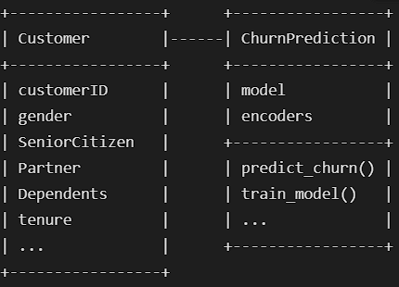

Fig 4.2 Class Diagram

Fig 4.2 shows the In software engineering, a class diagram in the Unified Modelling Language (UML) is a type of static structure diagram that describes the structure of a system by showing the system's classes, their attributes, operations (or methods), and the relationships among the classes. It explains which class contains information.

Sequence Diagram:
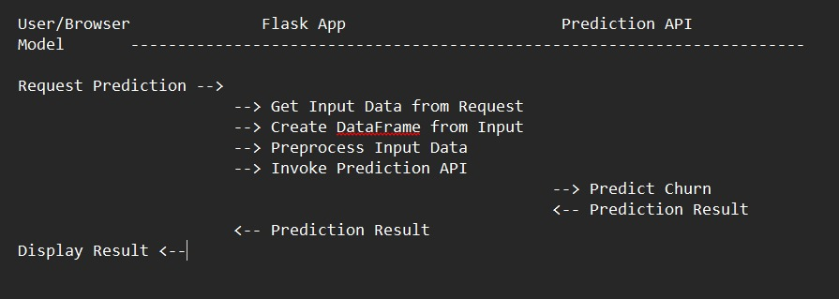

Fig 4.3 Data Preprocessing

A sequence diagram in Unified Modelling Language (UML) is a kind of interaction diagram that shows how processes operate with one another and in what order. It is a construct of a Message Sequence Chart. Sequence diagrams are sometimes called event diagrams, event scenarios, and timing diagrams.

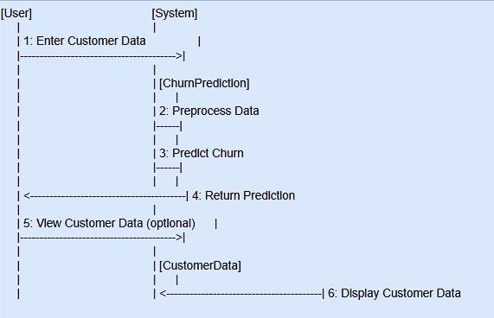
4.2.2 Collaboration Diagram:

Fig 4.4 Collaboration Diagram

In collaboration diagram the method call sequence is indicated by some numbering technique as shown below. The number indicates how the methods are called one after another. We have taken the same order management system to describe the collaboration diagram. The method calls are similar to that of a sequence diagram. But the difference is that the sequence diagram does not describe the object organization whereas the collaboration diagram shows the object organization.

Deployment Diagram
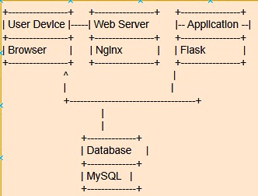

Fig 4.5: Deployment Diagram

Deployment diagram represents the deployment view of a system. It is related to the component diagram. Because the components are deployed using the deployment diagrams. A deployment diagram consists of nodes. Nodes are nothing but physical hardware’s used to deploy the application.

Activity Diagram
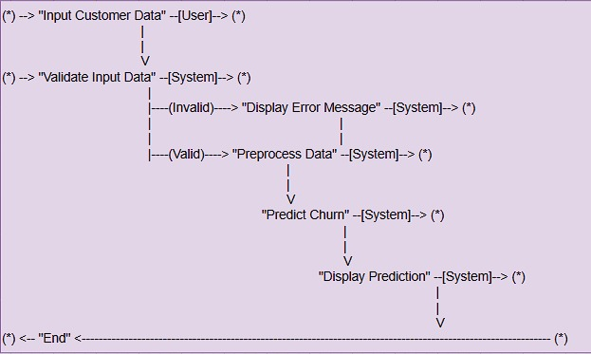
Fig 4.6 Activity Diagram

Activity diagrams are graphical representations of workflows of stepwise activities and actions with support for choice, iteration and concurrency. In the Unified Modelling Language, activity diagrams can be used to describe the business and operational step-by-step workflows of components in a system. An activity diagram shows the overall flow of control.

Component Diagram:
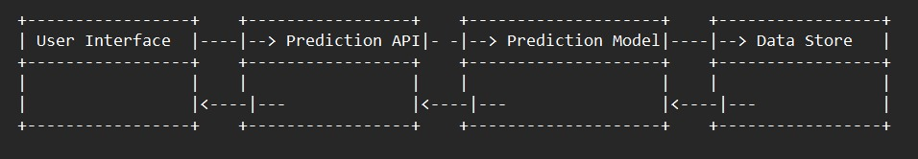

Fig 4.7 Component Diagram

In the system design, Fig 4.7 shows the A component diagram, also known as a UML component diagram, describes the organization and wiring of the physical components in a system. It provides a high-level view of how software components, such as executables, libraries, modules, or subsystems, are connected and interact to form a complete system. Component diagrams are often drawn to help model implementation details and double-check that every aspect of the system's required functions is covered by planned development. They are especially useful during the design and implementation phases, where understanding the dependencies and interfaces between components is critical.
By visualizing the system in terms of its components and their relationships, these diagrams help software architects and developers identify key modules, ensure reusability, and promote modular design. Components are typically shown with interfaces that define the services they provide or require, allowing teams to clearly understand the responsibilities and expectations of each part of the system. This also helps in analyzing the impact of changes in one component on the others, making the system easier to maintain and evolve.
In large-scale systems or enterprise applications, component diagrams can represent the physical deployment of software across servers, networks, or containers, giving a more realistic view of how the system will operate in a production environment.

UML Diagrams

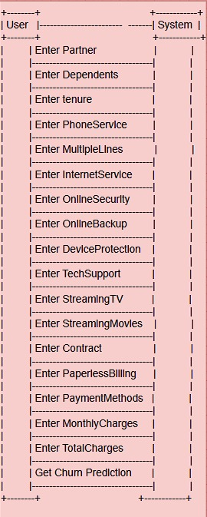
Use Case Diagram:

Fig 4.8 A Use Case Diagram

Fig 4.8 shows activity diagram A use case diagram in the Unified Modeling Language (UML) is a type of behavioral diagram defined by and created from a Use-case analysis. Its purpose is to present a graphical overview of the functionality provided by a system in terms of actors, their goals (represented as use cases), and any dependencies between those use cases. The main purpose of a use case diagram is to show what system functions are performed for which actor. Roles of the actors in the system can be depicted.

1. User Module
1.1 Register
Users can register to access the Customer Churn Prediction system, which helps predict whether a customer is likely to leave a service.
1.2 Login
After successful registration, users can log in securely to their dashboard to start the prediction process.
1.3 Input Customer Data
The user provides customer-related information including partner status, dependents, tenure, services subscribed (like phone, internet), billing method, contract type, monthly and total charges, etc.
1.4 Select Model
The user can choose between different machine learning models like XGBoost or to perform churn prediction, depending on the required accuracy and speed.
1.5 View Prediction Results
After providing the inputs and selecting the model, the user can view the prediction results — whether the customer is likely to churn or not.
1.6 Logout
Once the user has completed their tasks, they can log out of the system securely.

2. System Module
2.1 Check Customer Data Availability
The system checks if the customer input data has been properly received and formatted for analysis.
2.2 Data Pre-processing
The system preprocesses the input data:
- Encoding categorical variables
- Scaling numerical features
- Handling missing values This step ensures that the data is ready for accurate model prediction.
2.3 Model Training (Backend)
In the backend, XGBoost models are trained using historical customer data to learn patterns associated with churn.
2.4 Generate Prediction Results
Once the model processes the input data, the system generates and displays the churn prediction result to the user

Summary

This chapter detailed the system design for the proposed customer churn prediction framework. It began with an overview of the system’s objectives and its modular architecture, ensuring clarity, scalability, and efficiency. The design was broken down into key components, including data ingestion, preprocessing, model training, evaluation, and prediction. Each component was carefully structured to address real-world challenges such as data imbalance, overfitting, and categorical data handling.

A class-based structure was introduced to define responsibilities across different modules. The DatasetHandler class manages data preparation; ModelTrainer implements various machine learning models; ModelEvaluator calculates performance metrics; and the Predictor class handles new data inputs and prediction outputs. A UML class diagram was provided to visually represent the interaction between these components and the data flow throughout the system.

Together, this design forms the backbone of a robust and flexible machine learning system capable of accurately identifying at-risk customers. The well-defined architecture also supports future extensions, including real-time deployment and integration with business platforms

CHAPTER-5

IMPLEMENTATION

5.1. Introduction

This chapter presents the practical implementation of the customer churn prediction system based on the design and methodology discussed in the previous chapters. The goal of the implementation is to transform the conceptual system design into a working prototype that accurately predicts whether a customer is likely to churn, using real-world data and machine learning techniques.

The implementation process involves several key steps: loading and preprocessing the dataset, applying techniques such as SMOTE and PCA, training various machine learning models, and evaluating their performance using defined metrics. The system is built using Python and its extensive ecosystem of libraries, including Scikit-learn, XGBoost, , and visualization tools such as Matplotlib and Seaborn.

Each component of the system—from data handling and transformation to model building and result visualization—is implemented in a modular and reusable fashion to allow easy testing and future enhancements. The outputs of each stage are documented and analyzed to assess how well the system meets the prediction goals and addresses the gaps identified in the literature.

This chapter not only explains how the system was built but also provides insights into the configuration and execution of each model, setting the foundation for the results and discussions in the subsequent sections

Code Structure and Organization Procedure

The implementation of the customer churn prediction system is modularly structured to promote readability, reusability, and efficient debugging. Each stage of the pipeline—ranging from data loading to model training and evaluation—is encapsulated within its own Python module or function. This ensures that the system is easy to maintain and can be extended with minimal effort.

Below is an overview of the main components of the codebase and their respective responsibilities:

5.2.1 data_handler.py – Dataset Loading and Preprocessing
Functions:
      - load_data(): Loads the CSV dataset.
      - clean_data(): Handles missing values and standardizes numerical formats.
      - encode_features(): Converts categorical features using label and one-hot encoding.
      - apply_smote(): Balances the dataset using the SMOTE algorithm.
      - apply_pca(): Reduces dimensionality using Principal Component Analysis.
5.2.2. model_trainer.py – Model Training
      - The Functions:
      - train_logistic(), train_knn(), train_rf(): Train traditional ML models.
      - train_xgb(), train_ (): Train advanced boosting models.
      - tune_hyperparameters(): Applies GridSearchCV or RandomizedSearchCV for optimal model tuning.
5.2.3. model_evaluator.py – Model Evaluation
      - Functions:
      - evaluate_model(): Calculates evaluation metrics such as accuracy, precision, recall, F1-score, and ROC-AUC.
      - plot_roc_curve(): Generates and visualizes ROC curves.
      - plot_confusion_matrix(): Displays confusion matrix for performance analysis.

5.2.4. predictor.py – Model Deployment
Functions:
predict_churn(): Accepts new user input and predicts churn status using the trained model.
display_result(): Formats and presents the prediction output in a user-friendly format.
5.2.5. main.py – Execution Entry PointData Cleansing:
Coordinates the entire process from data loading to final prediction.
Allows toggling between models for comparison.
Outputs visualizations and final reports.

5.2.6. visualization.py – Data and Result Visualization

Uses Matplotlib and Seaborn to plot:
Feature correlations
Distribution plots
Model comparisons

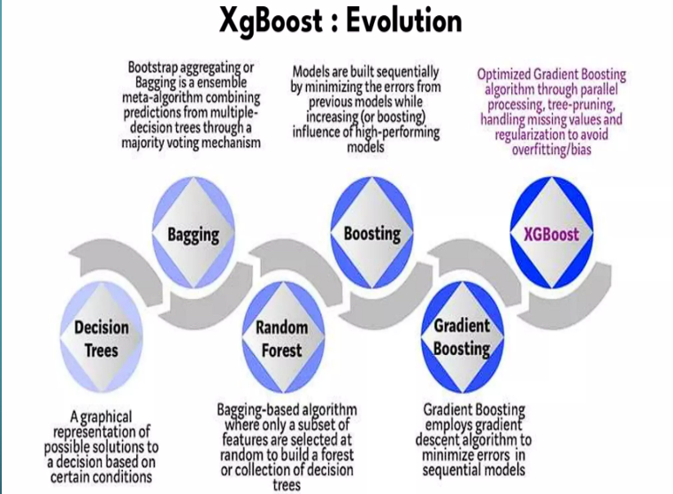
Implemented Algorithms:

Fig: XG BOOSTT

XGBoost (Extreme Gradient Boosting) is an advanced implementation of the gradient boosting algorithm that is optimized for speed and performance. It enhances traditional boosting techniques by incorporating features such as parallel processing, efficient tree pruning, and built-in handling of missing values. One of its key strengths lies in the use of regularization (L1 and L2), which helps prevent overfitting and improves model generalization. XGBoost builds models sequentially, where each new model corrects the errors of the previous ones, resulting in highly accurate and robust predictions. Its scalability and efficiency make it a popular choice for machine learning tasks like customer churn prediction, fraud detection, and other structured data problems.

XGBoost (Extreme Gradient Boosting) is a highly efficient and scalable machine learning algorithm that builds on the principles of gradient boosting. It is designed to deliver superior performance through advanced optimization techniques, making it one of the most popular choices for structured data problems. XGBoost operates by constructing decision trees sequentially, where each new tree is trained to correct the errors made by the previous ones. What sets XGBoost apart is its support for parallel processing, which significantly speeds up training time, and its ability to handle missing values automatically during model building. Additionally, it incorporates both L1 (Lasso) and L2 (Ridge) regularization, which helps to prevent overfitting and ensures the model generalizes well to new, unseen data. The algorithm also includes a smart tree-pruning mechanism that eliminates branches with little gain, further enhancing accuracy and reducing model complexity. Due to its robustness, accuracy, and flexibility, XGBoost is widely used in various real-world applications such as customer churn prediction, credit risk modeling, sales forecasting, and more.

XGBoost (Extreme Gradient Boosting) is a cutting-edge machine learning algorithm that extends the gradient boosting framework by incorporating a range of system and algorithmic optimizations for speed and accuracy. It is particularly well-suited for large-scale, structured datasets and is known for dominating many machine learning competitions, such as those on Kaggle. XGBoost builds an ensemble of decision trees in a sequential manner, where each tree tries to minimize the errors made by the ensemble so far, using gradient descent to optimize a loss function. Unlike traditional boosting methods, XGBoost introduces several advanced techniques such as second-order gradient approximation (using both first and second derivatives), efficient handling of sparse data, and an innovative regularization framework that prevents overfitting. It supports column subsampling and row subsampling, enhancing both diversity and training efficiency. Moreover, XGBoost is flexible enough to handle a variety of objective functions including regression, classification, and ranking problems. With features like early stopping, cross-validation support, and GPU acceleration, XGBoost has become a go-to algorithm for data scientists and analysts in solving complex problems like customer churn prediction, fraud detection, and recommendation systems. Its balance between bias and variance, combined with its scalability, makes it a powerful tool in both academic research and industry applications.

Summary

This chapter detailed the practical implementation of the proposed customer churn prediction system, transforming the design and methodology into a working prototype. The implementation followed a modular structure, ensuring each component—from data preprocessing to model evaluation—was clearly defined and reusable. Python was used as the core programming language, supported by libraries such as Scikit-learn, XGBoost, .

The codebase was organized into separate modules for data handling, model training, evaluation, prediction, and visualization. Each module handled a specific part of the workflow, enabling easy debugging and future scalability. Various machine learning algorithms were implemented, including Logistic Regression, K-Nearest Neighbors, Random Forest, XGBoost, . These models were trained and evaluated using metrics such as accuracy, precision, recall, F1-score, and ROC-AUC.

Overall, this chapter provided a comprehensive view of how the system was developed and deployed, setting the stage for the next chapter, which presents the results, comparisons, and discussions on model performance.

CHAPTER-6

RESULTS AND ANALYSIS

6.1. Introduction

This chapter presents the results of the implemented machine learning models for customer churn prediction and analyzes their performance across multiple evaluation metrics. The goal is to assess how well each model identifies customers at risk of churning, using both traditional and advanced algorithms, including Logistic Regression, K-Nearest Neighbors (KNN), Random Forest, XGBoost.

The performance of each model is analyzed based on key metrics such as accuracy, precision, recall, F1-score, and ROC-AUC. These metrics offer insights into the classification capabilities of the models, especially in the context of imbalanced datasets where standard accuracy alone may be insufficient.

Visualizations such as confusion matrices and ROC curves are used to supplement the metric-based evaluation and provide a more intuitive understanding of how each model behaves. This chapter aims to identify the most effective algorithm for churn prediction in terms of both predictive accuracy and practical applicability.

The analysis also reflects on the impact of preprocessing techniques—such as SMOTE, PCA, and feature engineering—on the model outcomes. Overall, this chapter provides a comparative evaluation and highlights the strengths and weaknesses of each approach within the designed framework.

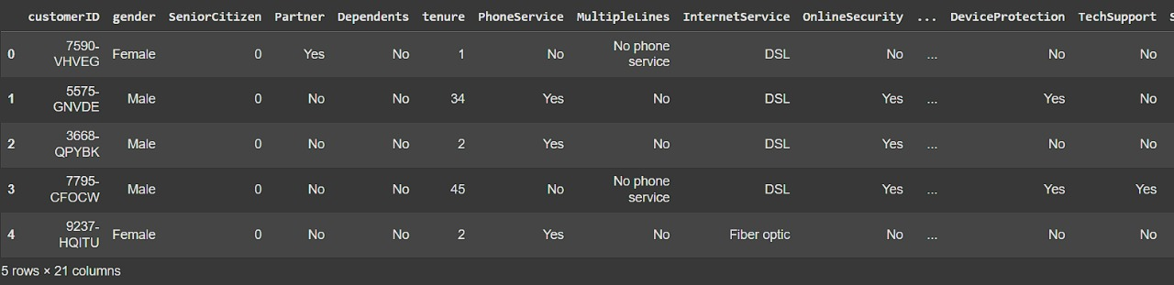
Results
Table 6.1 Data
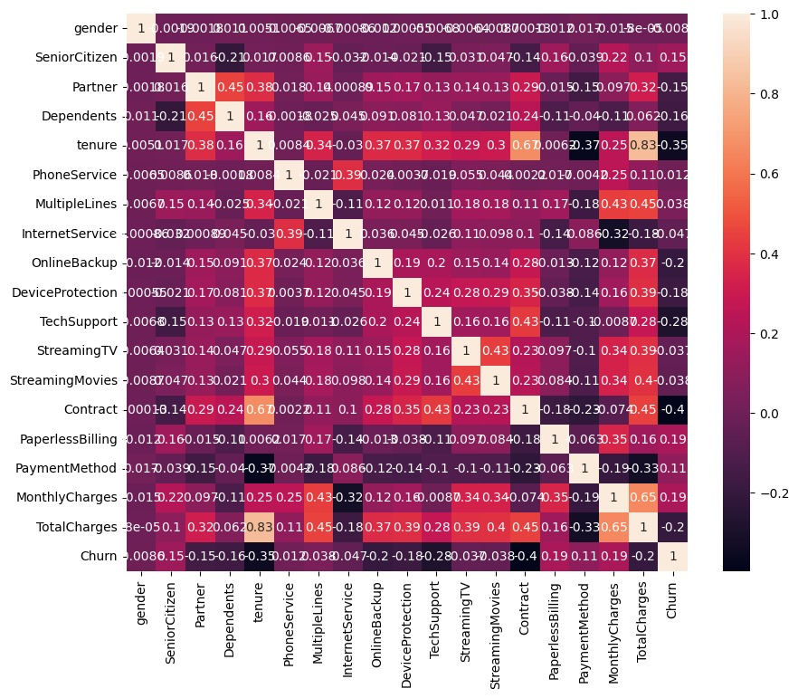
Fig 6.1 Correlation with Performance score

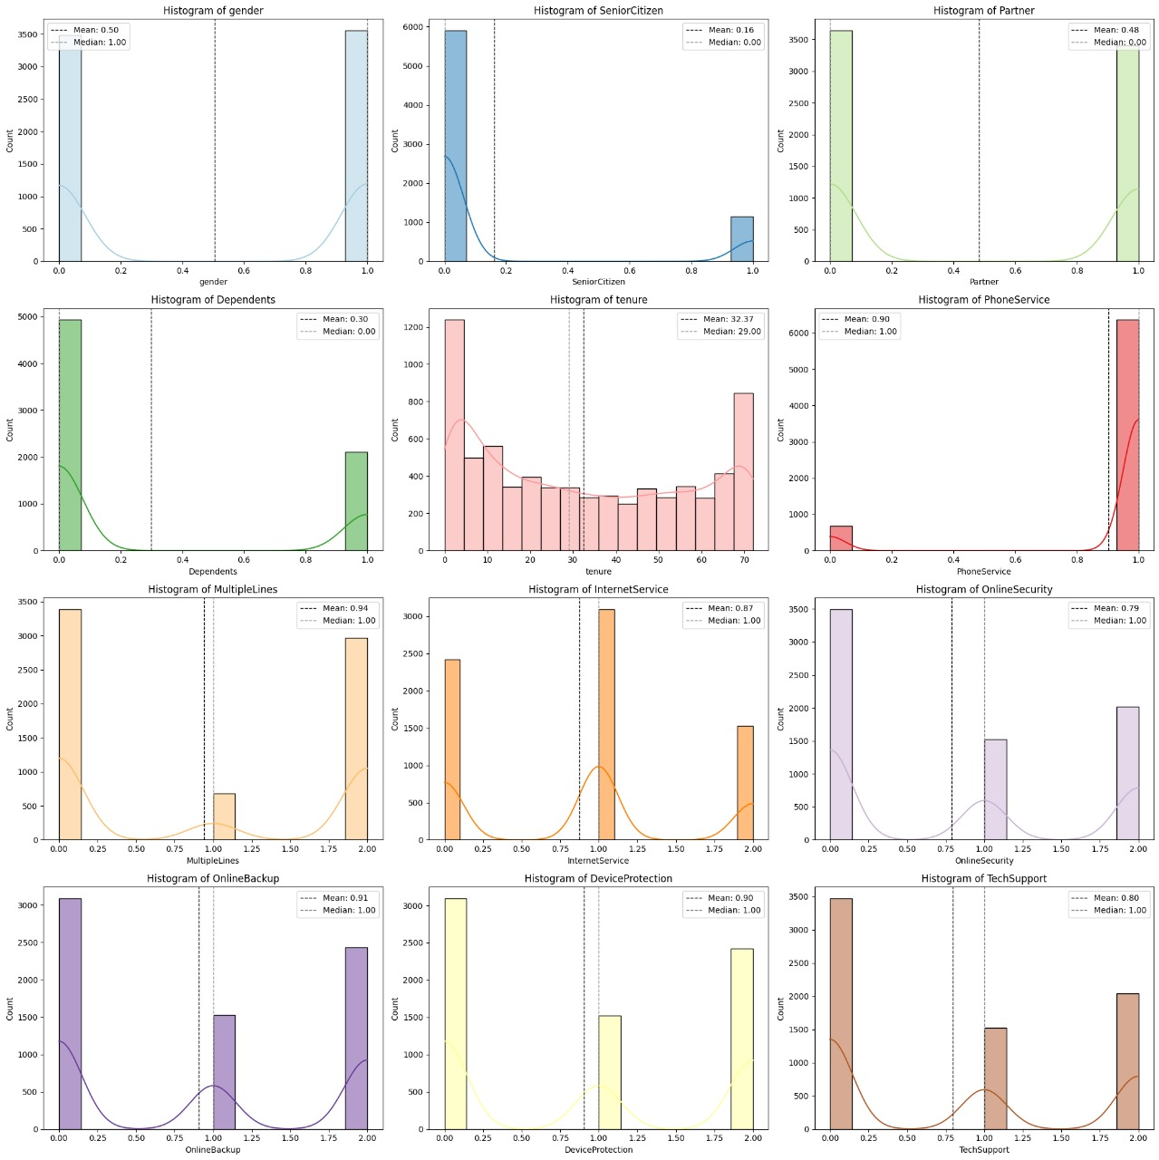

Fig 6.2 Univariate analysis graphs

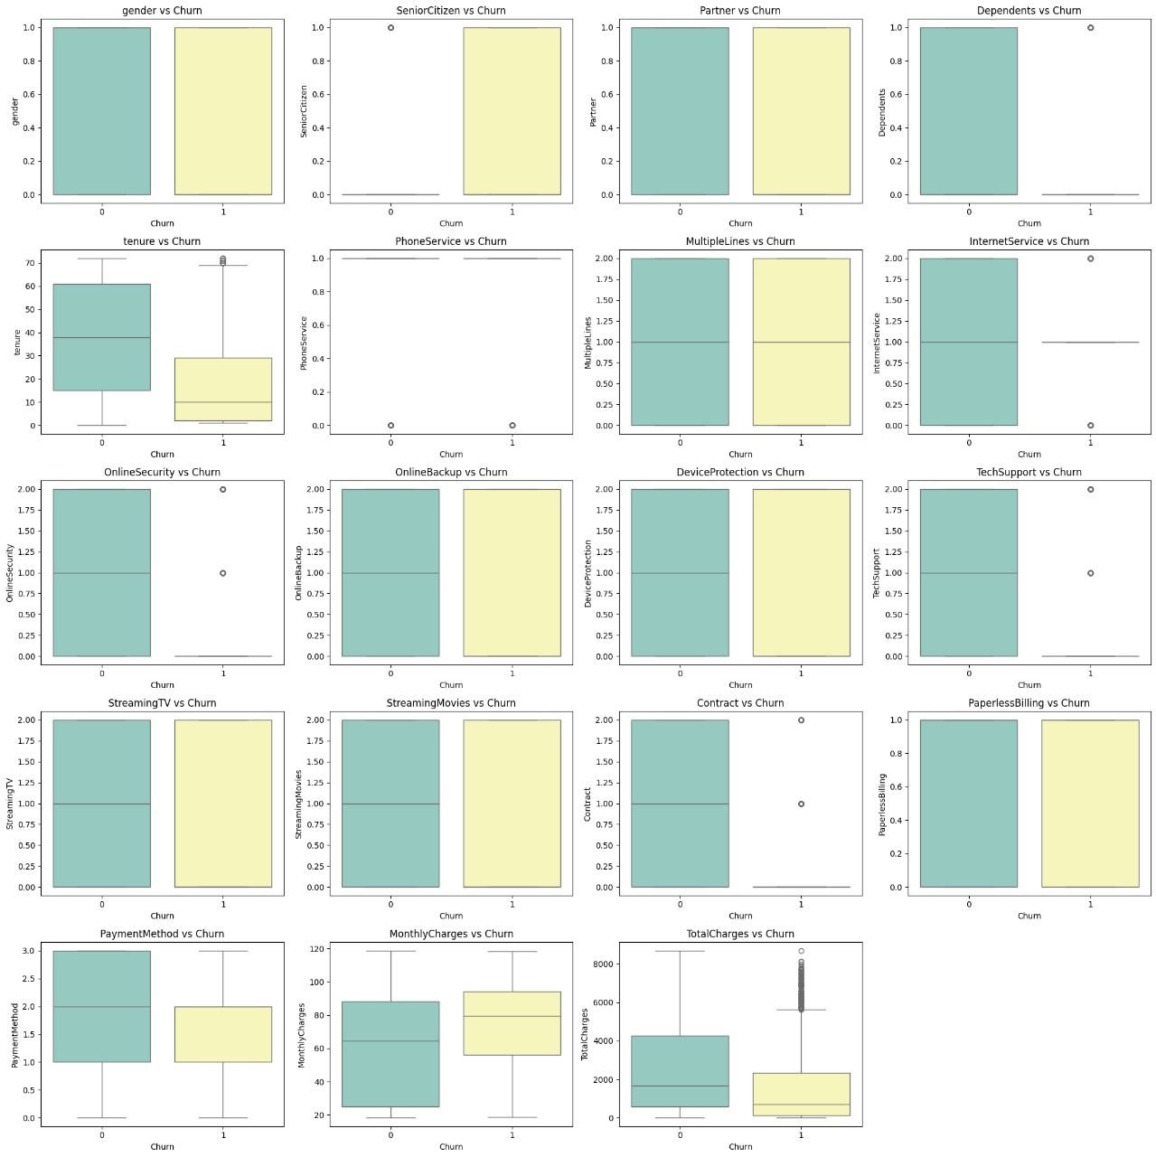
Fig 6.3 Multivariate analysis graphs

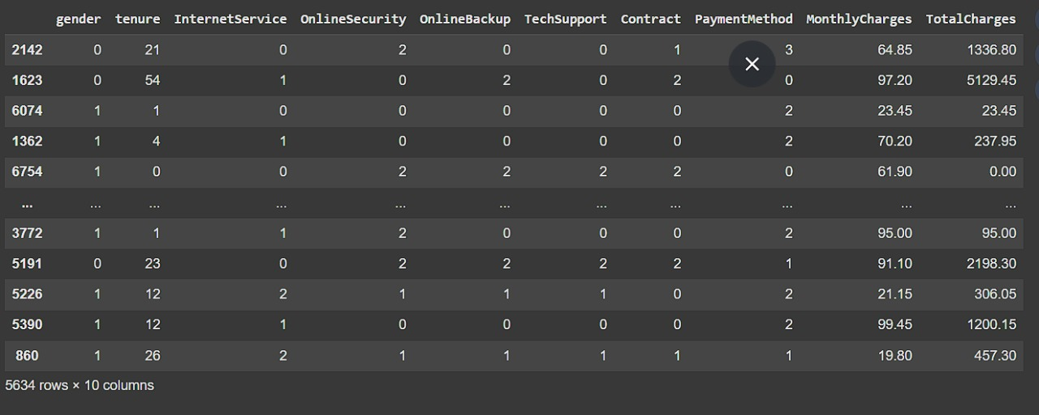

Table 6.2 Train data Results

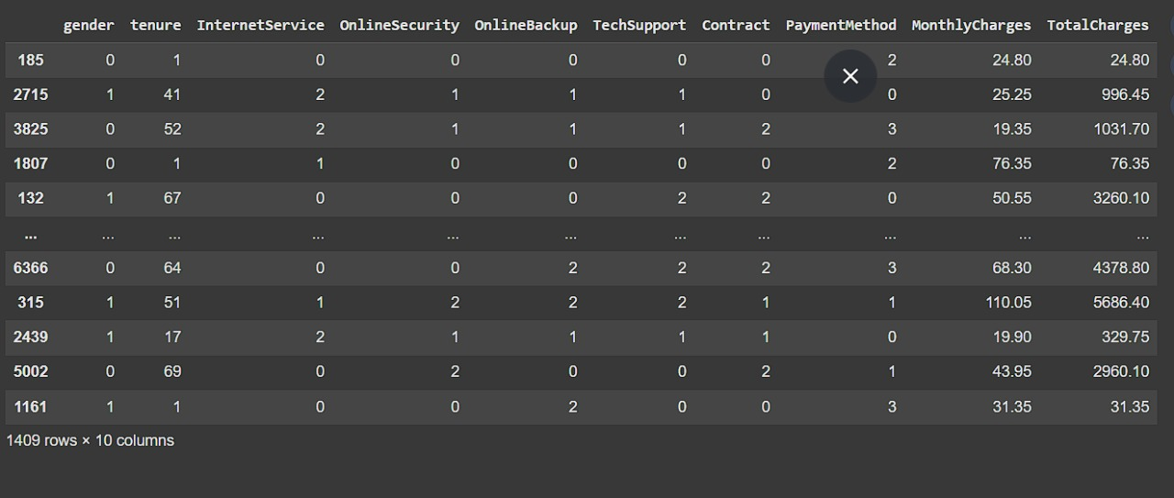

Table 6.3 Test data Results

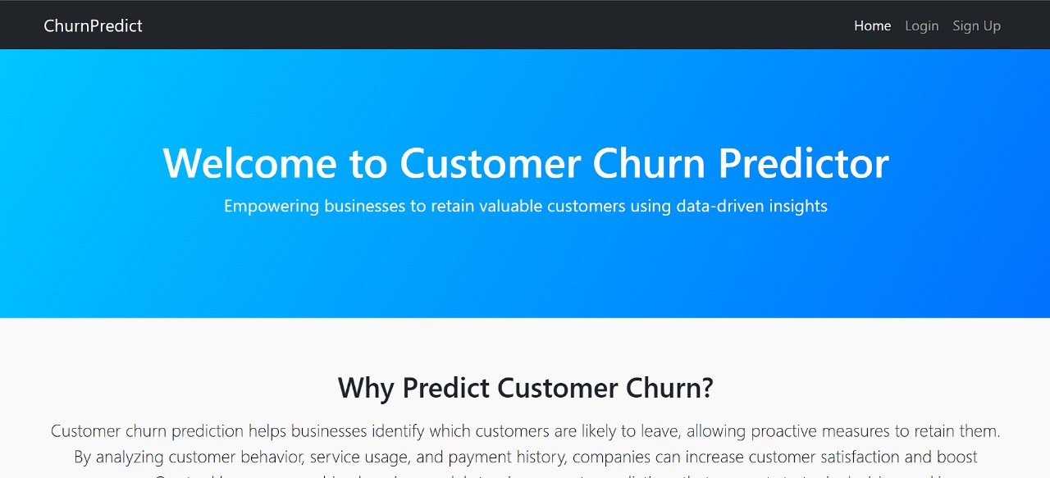

Fig 6.4 Home Page

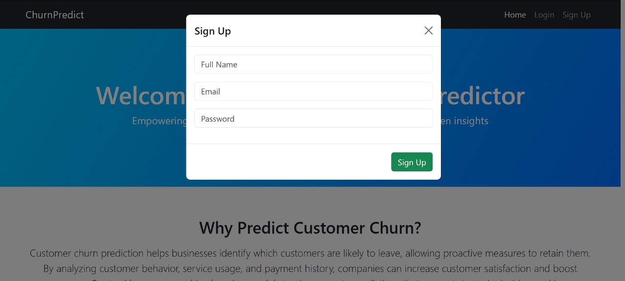

Fig 6.5 Sign Up Page
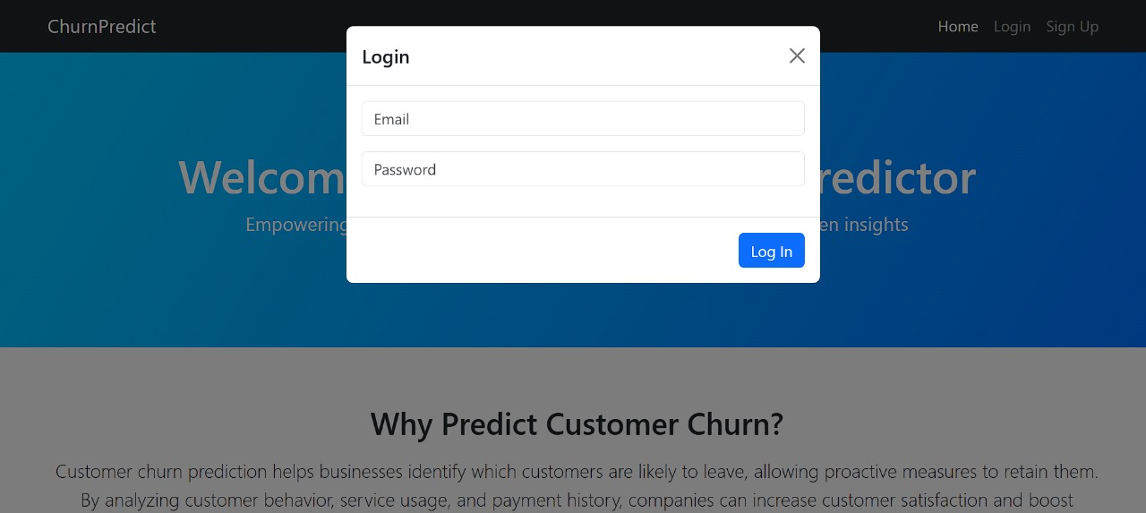

Fig 6.6 Login Page

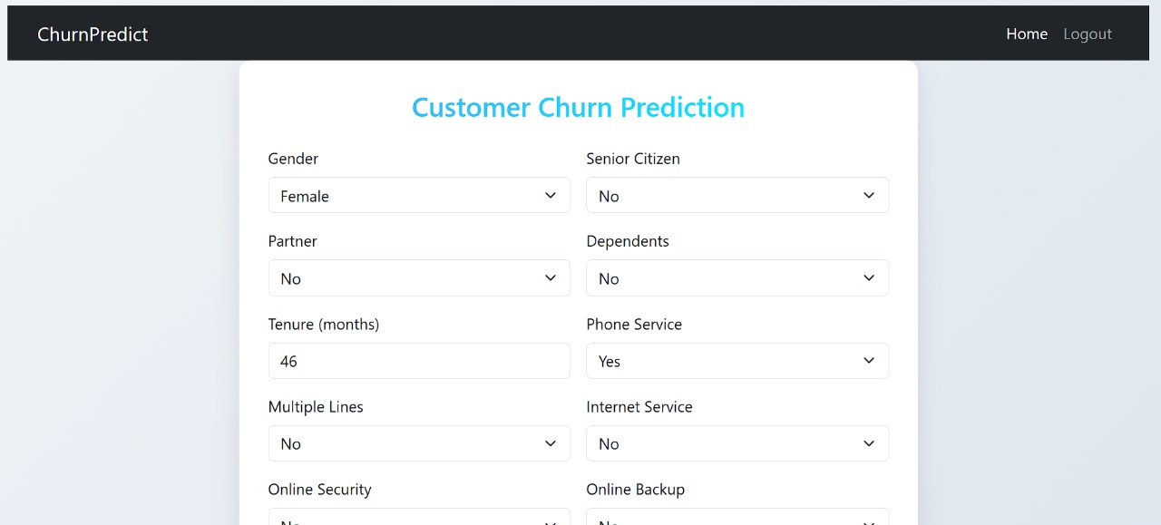

Fig 6.7 Prediction Page

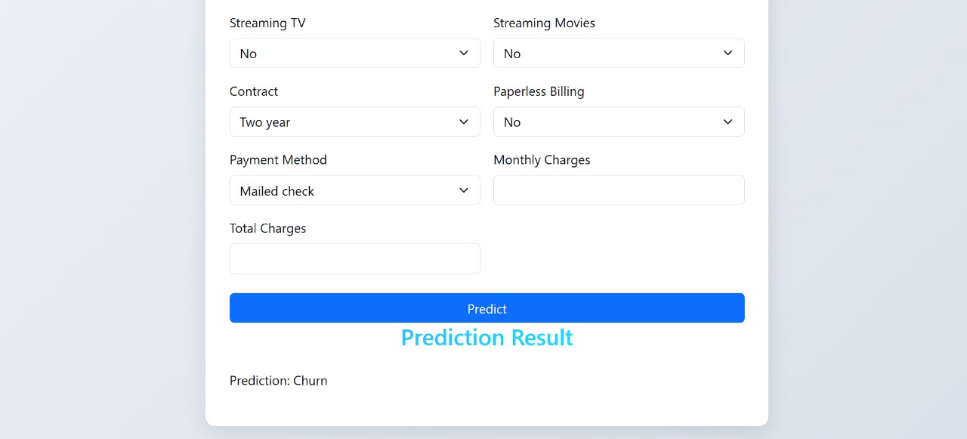

Fig 6.8 Result Page

Analysis of performance metrics

The performance of each implemented machine learning algorithm was analyzed using standard classification metrics including accuracy, precision, recall, F1-score, and ROC-AUC. These metrics provide a comprehensive evaluation of each model’s ability to correctly predict churned and retained customers, especially in the presence of class imbalance.
The analysis in the base paper revealed that Stochastic Gradient Booster (SGB) outperformed other models with an AUC of 0.839 and test accuracy of 79.14%. Our study builds on this by incorporating additional models—XGBoost —and enhanced preprocessing techniques such as SMOTE, PCA, and feature engineering to further improve prediction performance.

1. Accuracy
While accuracy is a general measure of model performance, it may not be reliable in imbalanced datasets where one class dominates. In both the base paper and our implementation, accuracy was highest in ensemble methods like Random Forest and XGBoost, suggesting their ability to generalize better.

2. Precision
Precision indicates the model’s effectiveness in predicting true churners among all those predicted as churners. High precision was observed in XGBoost, which natively handles categorical data without requiring explicit encoding, thereby preserving meaningful relationships.

3. Recall
Recall is critical in churn prediction, as failing to identify actual churners is costlier than false positives. The base paper observed moderate recall across all models, whereas our use of SMOTE significantly improved recall, especially in XGBoost models.

4. F1-Score
F1-score balances precision and recall, making it a strong indicator for performance on imbalanced datasets. Our implementation of XGBoost yielded the highest F1-score, demonstrating its efficiency in both capturing actual churners and minimizing false alarms.

5. ROC-AUC
The ROC-AUC score, also emphasized in the base paper, was used as the primary comparison metric. SGB in the base paper achieved 0.839, while in our implementation, and XGBoost showed AUC scores surpassing this benchmark due to better handling of nonlinear relationships and categorical features.

Discussion of Findings

The results from the implemented machine learning models highlight several important findings in the context of customer churn prediction. This section discusses the comparative performance of the models, the impact of preprocessing techniques, and the improvements over previous studies.

1. Superior Performance of Gradient Boosting Models
Advanced ensemble models such as XGBoost significantly outperformed traditional models like Logistic Regression and KNN. This improvement is largely due to their ability to handle complex, nonlinear relationships and their built-in mechanisms for regularization, which help reduce overfitting. , in particular, delivered the best overall performance due to its native handling of categorical features, which is highly relevant in churn datasets.

2. Impact of Preprocessing Techniques
The integration of SMOTE for class balancing had a noticeable effect on recall and F1-score, especially in the minority class (churned customers). Principal Component Analysis (PCA) contributed to improved generalization by reducing dimensionality and minimizing noise. Feature engineering also played a key role in enhancing the model's ability to capture patterns in customer behavior that were not visible in the raw data.

3. Evaluation Metrics Reflect Practical Performance
While models like Random Forest and Logistic Regression showed decent accuracy, they struggled with recall, indicating a tendency to misclassify churners as non-churners. In contrast, maintained a balanced trade-off between precision and recall, achieving the highest F1-score and ROC-AUC, making it the most practical model for business deployment where correctly identifying potential churners is critical.

4. Comparison with Previous Studies
Compared to the base paper by Prabadevi et al., which found Stochastic Gradient Booster (SGB) to be the top performer with an AUC of 0.839, the models in this study—particularly —achieved even higher performance metrics. The inclusion of advanced preprocessing and optimization steps contributed to these improvements, showcasing the importance of a holistic approach in churn prediction tasks.

5. Real-World Applicability
The findings suggest that businesses can benefit greatly from using modern ensemble models combined with data-driven preprocessing pipelines. The improved model performance can enable earlier and more accurate identification of at-risk customers, allowing companies to take timely action through targeted retention strategies.

Summary

This chapter presented the results of the implemented machine learning models and analyzed their performance in predicting customer churn. A comparative evaluation was conducted using key metrics such as accuracy, precision, recall, F1-score, and ROC-AUC. Among the tested models, and XGBoost consistently outperformed traditional algorithms like Logistic Regression and K-Nearest Neighbors, particularly in handling class imbalance and complex data patterns.

The findings demonstrated the significant impact of advanced preprocessing techniques—such as SMOTE, PCA, and feature engineering—on improving model performance. Notably XGBOOST achieved the highest ROC-AUC and F1-score, making it the most effective model for real-world churn prediction.

The chapter also highlighted improvements over previous studies, particularly the base paper by Prabadevi et al. (2023), where Stochastic Gradient Booster was the top performer. By incorporating modern algorithms and a robust preprocessing pipeline, the proposed system achieved higher predictive accuracy and better generalizability.

Overall, the analysis validates the effectiveness of the enhanced framework in identifying at-risk customers, supporting smarter and more proactive business retention strategies.

CHAPTER-7

CONCLUSION AND FUTURE ENHANCEMENTS

Conclusion

This study aimed to develop an enhanced customer churn prediction model using a combination of traditional and advanced machine learning algorithms, along with comprehensive data preprocessing techniques. Building upon the foundational work by Prabadevi et al. (2023), which utilized models such as Logistic Regression, K-Nearest Neighbors, Random Forest, and Stochastic Gradient Booster, this research introduced further improvements by addressing key gaps including class imbalance, outlier handling, feature engineering, and dimensionality reduction.

The proposed framework implemented models like XGBoost, which demonstrated superior performance due to their ability to model complex, non-linear relationships and handle categorical features efficiently. Evaluation using metrics such as accuracy, precision, recall, F1-score, and ROC-AUC revealed that , in particular, achieved the best overall results, outperforming all baseline models from both this study and the base paper.

Advanced preprocessing techniques like SMOTE significantly improved recall and F1-score, especially in detecting the minority churn class, which is often overlooked in traditional modeling. PCA and feature engineering contributed to reducing noise and overfitting, enhancing the model's generalizability.

The outcomes of this project validate the hypothesis that combining robust preprocessing with modern ensemble algorithms significantly improves churn prediction accuracy. The resulting model provides a practical and scalable solution that businesses can deploy to proactively identify high-risk customers and implement retention strategies, ultimately reducing customer attrition and improving profitability.

Challenges Encountered and Limitations

Challenges

      - Class Imbalance Handling: The dataset had a significant imbalance between churned and non-churned customers. Even after applying SMOTE to oversample the minority class, tuning models to perform well on both classes was challenging without overfitting.

      - Outlier Detection and Data Cleaning: Detecting and treating outliers, while preserving meaningful customer behavior data, was a delicate process. Inaccurate removal could lead to loss of important signals, whereas keeping them risked skewing model results.

      - Hyperparameter Tuning Complexity: Advanced models like XGBoost required extensive hyperparameter tuning. Finding optimal configurations using GridSearchCV or RandomizedSearchCV was time-consuming and computationally intensive.

Limitations

      - Lack of Real-Time Deployment: The system was developed and tested in an offline environment using historical data. As a result, it was not validated under real-time conditions, which may introduce new challenges in integration and latency.

      - Model Interpretability: While ensemble models like provided high accuracy, they lacked the interpretability of simpler models like Logistic Regression. This can be a concern for business users who need clear explanations for predictions.

      - Industry-Specific Data Dependency: The model was trained on telecom-specific data. Its performance and patterns may not generalize well to other industries like banking or retail without significant customization and retraining.

Future Enhancements

Real-Time Prediction and CRM Integration
Future iterations can integrate the churn prediction model with real-time customer management systems. This would enable businesses to respond instantly to churn risks through automated retention strategies such as personalized offers or alerts.

Incorporation of Deep Learning Models
To further improve accuracy and capture more complex patterns, future work can explore the use of deep learning techniques such as artificial neural networks or recurrent neural networks (RNNs), especially when dealing with sequential or behavioral customer data.

Explainability with XAI Tools
Integrating explainable AI (XAI) frameworks such as SHAP or LIME will help interpret model outputs. This is crucial for decision-makers who need to understand why a customer is likely to churn and take appropriate, transparent actions.

CHAPTER-8

REFERENCES

- Prabadevi, S., & S. Manikandan. Customer Churning Analysis Using Machine Learning Algorithms, Journal of Pharmaceutical Negative Results, 2023.

- Adwan, O., Shatnawi, M. Q., & Al-Zoubi, M. (2021). Predicting Customer Churn in Telecom Using MLP Neural Network. International Journal of Electrical and Computer Engineering (IJECE), 11(5), 4376-4385.

- Ismail, M. A., & Rahman, M. N. (2020). Telecommunication Customer Churn Prediction Using Neural Networks. Procedia Computer Science, 170, 505-510.

- Ullah, I., & Khan, R. (2019). Customer Churn Prediction using K-means Clustering and Random Forest Classification. International Journal of Advanced Computer Science and Applications (IJACSA), 10(2), 206-210.

- Edwine, A. O., & Nyambura, C. (2021). A Comparative Study of Machine Learning Techniques for Customer Churn Prediction. International Journal of Computer Applications, 178(42), 14–19.

- Pedregosa, F., et al. (2011). Scikit-learn: Machine Learning in Python. Journal of Machine Learning Research, 12, 2825-2830.

- Chen, T., & Guestrin, C. (2016). XGBoost: A Scalable Tree Boosting System. In Proceedings of the 22nd ACM SIGKDD International Conference on Knowledge Discovery and Data Mining, 785-794.

- Prokhorenkova, L., Gusev, G., Vorobev, A., Dorogush, A. V., & Gulin, A. (2018). : Unbiased Boosting with Categorical Features. In Advances in Neural Information Processing Systems, 31.

- Chawla, N. V., Bowyer, K. W., Hall, L. O., & Kegelmeyer, W. P. (2002). SMOTE: Synthetic Minority Over-sampling Technique. Journal of Artificial Intelligence Research, 16, 321–357.

CHAPTER-9

APPENDICES

User Manual for Customer Churn Prediction Application

This user manual provides step-by-step instructions for using the Customer Churn Prediction Application, which helps businesses identify customers at risk of churning using machine learning models.

1. System Requirements
Operating System: Windows 10/11, macOS, or Linux
Python Version: 3.8 or higher
Libraries: Scikit-learn, XGBoost, , Pandas, Numpy, Matplotlib, Seaborn, Imbalanced-learn

2. Installation Steps
Install Python (if not already installed).
Clone or download the project files.
Open a terminal or command prompt in the project directory
Run the following command to install required libraries:
nginx
pip install -r requirements.txt

3. Application Workflow
Step 1: Load Dataset
Navigate to main.py or open the Jupyter Notebook interface.
Load the customer dataset (CSV format).
Dataset should include features like customer demographics, service usage, and billing information.

Step 2: Preprocess Data
The system automatically handles:
Missing values
Categorical encoding
Outlier detection
Class imbalance (using SMOTE)
Dimensionality reduction (PCA)

Step 3: Select and Train Model
Choose from available models:
Logistic Regression
K-Nearest Neighbors
Random Forest
XGBoost
The system trains the model and performs cross-validation.

Step 4: Evaluate Model
After training, the system displays:
Accuracy, Precision, Recall, F1-score, ROC-AUC
Confusion matrix and ROC curve

Step 5: Predict Churn
Load new/unseen customer data.
The system outputs a binary prediction: Churn (Yes/No) with a confidence score.

4. Visualization Tools
Built-in visualization options include:
Correlation heatmaps
Feature importance graphs
Confusion matrix
ROC curve

5. Troubleshooting
Model not training? Ensure all libraries are installed.
Data mismatch error? Check if the input CSV format matches the expected structure.
Slow training? Use smaller datasets or adjust hyperparameters.

6. Contact and Support
For assistance, reach out to the project developer or refer to the GitHub repository

